MACHINE LEARNING-BASED ENERGY CONSUMPTION FORECASTING IN SMART GRIDS
ABSTRACT
The integration of machine learning-based energy consumption forecasting in smart grids has wide-ranging applications across various sectors. In the utility industry, accurate forecasting supports optimized energy generation, load balancing, and infrastructure planning, leading to improved operational efficiency and cost savings. For renewable energy integration, precise forecasting enables better utilization of intermittent energy sources, enhancing grid stability and reducing reliance on fossil fuels. Additionally, in smart buildings and homes, energy consumption forecasts empower occupants to manage energy usage effectively, optimize comfort levels, and reduce utility bills. Traditional methods for energy consumption forecasting often rely on statistical techniques or time series analysis, which may struggle to capture the complexities of smart grid data. These methods typically require manual feature engineering and parameter tuning, limiting their adaptability and scalability. Moreover, traditional approaches may overlook contextual factors such as weather conditions, holidays, and user behavior patterns, leading to suboptimal forecasts. The increasing complexity and variability of smart grid data further challenge traditional forecasting methods, necessitating more advanced and data-driven approaches. The proposed system utilizes machine learning algorithms to improve the accuracy and efficiency of energy consumption forecasting in smart grids. This work leverages a diverse set of features, including temporal information (date, time), environmental factors (temperature, humidity), and grid characteristics, to train forecasting models. By employing regression algorithms, this work aims to capture complex relationships and patterns in the data. Additionally, this work explore ensemble learning techniques and model optimization strategies to enhance forecasting performance further.

CHAPTER 1
INTRODUCTION
1.1 Overview
The integration of machine learning-based energy consumption forecasting in smart grids heralds a transformative era in the energy sector. It encompasses a multifaceted approach that not only revolutionizes utility operations but also extends its benefits to various sectors. At its core, this integration aims to enhance the efficiency and effectiveness of energy generation, distribution, and consumption processes within smart grid infrastructures. By leveraging advanced algorithms and diverse datasets, this paradigm shift promises to address the challenges posed by the increasing complexity and variability of modern energy systems.
1.2 Problem Statement
In the realm of energy consumption forecasting, traditional methods often fall short in capturing the intricacies of smart grid data. They struggle to adapt to the dynamic nature of energy usage patterns and may overlook crucial contextual factors. This limitation hampers the ability of utilities to optimize energy generation and distribution, leading to inefficiencies and increased costs, inaccurate forecasts hinder the seamless integration of renewable energy sources, impeding progress towards sustainable energy goals. Thus, there is a pressing need for more advanced and data-driven approaches to energy consumption forecasting that can overcome these challenges and provide reliable predictions.
1.3 Research Motivation
The motivation behind this research stems from the recognition of the pivotal role that accurate energy consumption forecasting plays in shaping the future of energy systems. By improving forecasting accuracy, we can unlock a myriad of benefits, including enhanced grid stability, reduced reliance on fossil fuels, and greater cost savings. Additionally, empowering consumers with actionable insights into their energy usage promotes energy conservation and efficiency. This research seeks to capitalize on the potential of machine learning algorithms to revolutionize energy forecasting and pave the way for a more sustainable and resilient energy ecosystem.
1.4 Existing Systems
Traditional energy consumption forecasting systems often rely on statistical techniques or time series analysis, which may struggle to keep pace with the complexities of smart grid data. These methods typically require manual intervention for feature engineering and parameter tuning, limiting their adaptability and scalability. Moreover, they may fail to account for contextual factors such as weather conditions and user behavior patterns, leading to suboptimal forecasts. As such, there is a growing recognition of the need for more advanced and data-driven approaches to energy forecasting, which machine learning algorithms can provide.
1.5 Research Objective
The primary objective of this research is to develop and deploy machine learning-based energy consumption forecasting models that can accurately predict future energy demand within smart grid environments. This entails leveraging diverse datasets encompassing temporal information, environmental factors, and grid characteristics to train robust forecasting models. By harnessing the power of regression algorithms, ensemble learning techniques, and model optimization strategies, we aim to enhance forecasting accuracy and efficiency, ultimately driving improvements in operational efficiency, cost savings, and sustainability within the energy sector.
1.6 Need
The need for advanced energy consumption forecasting methodologies is underscored by the increasingly complex and dynamic nature of modern energy systems. With the proliferation of renewable energy sources and the advent of smart grid technologies, traditional forecasting methods are proving inadequate in meeting the evolving demands of the energy sector. There is a critical need for more sophisticated approaches that can adapt to changing conditions, incorporate diverse data sources, and provide actionable insights for stakeholders across the energy value chain. By addressing these needs, machine learning-based forecasting systems can unlock significant value and drive innovation in energy management and distribution.
1.7 Application
The applications of machine learning-based energy consumption forecasting extend across various domains, encompassing utilities, renewable energy integration, and smart buildings/homes. Within the utility sector, accurate forecasting supports optimized energy generation, load balancing, and infrastructure planning, leading to improved operational efficiency and cost savings. In the context of renewable energy integration, precise forecasting enables better utilization of intermittent energy sources, enhancing grid stability and reducing reliance on fossil fuels. Additionally, in smart buildings and homes, energy consumption forecasts empower occupants to manage energy usage effectively, optimize comfort levels, and reduce utility bills. These applications underscore the transformative potential of machine learning in shaping the future of energy systems and driving sustainable development.

CHAPTER 2
LITERATURE SURVEY
Smart Grids (SG) have emerged as a solution to the increasing demand on energy worldwide. The grid refers to the traditional electrical grid that is a collection of transmission lines, substations, and other components that make sure energy is delivered from the power plant to the home or business [1]. The smartness in the SG resides in the two-way communication between the utility and the customers, in addition to the sensing along the lines. The main components of a SG are controls, computers, automations, in addition to other new technologies that are working together to accommodate for the quick increase in the energy demand. The SG has many benefits among which we state: more efficient energy transmission, improving security, reducing peak demand which helps with the decrease of electricity rates, etc. SG are also known by the use of renewable energy sources.
The prediction and scheduling are two of the main pillars of efficient Energy Management Systems (EMS). EMSs are very crucial for the well-functioning of the SG. They are responsible for managing the power flux within the SG elements in order to minimize the costs and optimize the quality [2].
The prediction of the energy consumed by different appliances is one of the building blocks of the concept of SGs. The energy consumption can be seen as a nonlinear time series with a number of complex factors [3]. With many renewable energy sources used in the SGs, the energy prediction methods are getting more and more accurate, and hence, the prediction becomes a crucial part in the efficient planning of the entire SG.
There are different approaches that are used for the prediction of the energy consumption. The most popular ones use machine learning (ML).
Machine learning (ML) is one of the growing technical fields that merge between computer science and statistics. It tackles the issue of building computers that learn through experiences and hence provide more improved algorithms. ML keeps witnessing advances thanks to the new algorithms and the availability of online data, in addition to the accessibility of the computing power [4]. Artificial Neural Networks (ANN) are one of the ML algorithms are widely used in this context.
ANNs have seen light in the early 1940s but have not been widely used until lately. They became very popular thanks to the outstanding results they offer. They are very powerful with large datasets which gives the neural network enough data to train the model. In brief, ANNs are inspired by the way the brain processes information. They build an informational processing model that mimics the work of the neurons in the brain [5]. Their ability to learn quickly is what makes ANNs very powerful. This learning is done through an information flow that goes in two directions. Patterns from the training dataset are given to the ANN through the input neurons, then goes through the hidden layers and arrives to the output neurons.
Genetic Algorithms (GA) are considered the best solution for task and operation scheduling. They emerged from the research of Mr. John Holland conducted at the University of Michigan in 1960. However, it took them almost 30 years to become popular. The main purpose of GA is to solve complex problems where deterministic algorithms are considered an expensive solution. The Travelling Salesman Problem or the Knapsack problem are cases in point [6].
ANN and GA models are usually implemented in commodity computers or lately in Raspberry Pis. The NI CompactRIO is considered as a good alternative for deploying the ANN algorithms.
NI CompactRIO is a high-performance embedded controller with Input/Output modules. It has two targets: a real-time controller chassis, and an FPGA module. It includes a microprocessor to implement control algorithms and offer a support of a large pool of frequencies. The FPGA module is mainly used to accommodate for the high speed of certain modules and even certain programs. It deals with the data streaming from the I/O modules attached to the CompactRIO. The FPGA module is brought by Xilinx Virtex. The CompactRIO is programmable using a specific graphical programming language named LabVIEW. This latter allows a better visualization of the data and an intuitive and easy way to implement control approaches.
In this paper, we are training an ANN model to predict the energy consumed by different appliances in a building. The model is developed in Python programming language but interfaced with LabVIEW for a potential integration in the NI CompactRIO.
The rest of the paper is organized as follows: Sect. 2 presents the scope of the research project under which this work is done. Section 3 contains the background of our work. In Sect. 4, we present the implementation steps and discussing the results obtained. Then, we conclude and present our future work in Sect. 5.
2.2 Related Works
A lot of work has been carried on in this area by different researchers in the community. Authors in [7] are presenting a structure of a home energy management system to determine the best day-ahead scheduling for the different appliances. This scheduling is based on the hour price and the peak power-limiting-based demand response strategies. In addition to that, they introduced a realistic test-case in order to validate their schedule. The test showed a significant drop in the energy consumed by the different appliances thanks to the schedule they designed.
Sou Kin Cheong et al. presented in [8] a scheduling method for smart home appliances based on mixed integer linear programming. Furthermore, they took into consideration the expected duration and peak power consumption of the appliances. Based on a previously defined tariff, the proposed schedule achieved about 47% of cost saving. Furthermore, the authors demonstrated that very good solutions can be obtained using very little computational power.

Regarding the energy consumption prediction, a good amount of work has been published representing different attempts to predict the energy consumed by different appliances. Elkonomou presented in [9] a prediction method based on artificial neural network. In order to select the best architecture, the multilayer perceptron model was used to make a set of tests to select the one with the best generalization. Actual data about input and output was used in the training, validation, and testing process.
Authors in [10] are stating the fact that the building energy consumption prediction is crucial for efficient energy planning and management. To do the prediction, they are presenting a model that is data-driven and that allows for the energy consumption prediction. The review shows that the area of energy consumption prediction has a good amount of gaps that require more research to be filled: the prediction of long-term energy consumption, the prediction of energy consumed within residential buildings, and the prediction of energy consumed by the lighting in buildings. The lack of research in these areas can be due to the relatively small amount of data that is available.
According to [11], [12], and [13], short-term forecasts are typically helpful for scheduling generation capacity and short-term maintenance, evaluating short-term energy storage usage, as well as real-time control of building energy systems and optimising fuel purchase plans.

On the other hand, choices regarding the installation of new distributed generation and storage systems as well as the creation of effective demand response techniques10 are made using medium- to long-term projections [14]. Planning and trading on energy markets at the regional level may benefit from anticipating aggregated electricity usage over the medium- to long-term[15]

.

CHAPTER 3
EXISTING METHODOLOGY
Support Vector Machine
Support Vector Machine or SVM is one of the most popular Supervised Learning algorithms, which is used for Classification as well as Regression problems. However, primarily, it is used for Classification problems in Machine Learning. The goal of the SVM algorithm is to create the best line or decision boundary that can segregate n-dimensional space into classes so that we can easily put the new data point in the correct category in the future. This best decision boundary is called a hyperplane. SVM chooses the extreme points/vectors that help in creating the hyperplane. These extreme cases are called as support vectors, and hence algorithm is termed as Support Vector Machine. Consider the below diagram in which there are two different categories that are classified using a decision boundary or hyperplane:
EXAMPLE: SVM can be understood with the example that we have used in the KNN classifier. Suppose we see a strange cat that also has some features of dogs, so if we want a model that can accurately identify whether it is a cat or dog, so such a model can be created by using the SVM algorithm. We will first train our model with lots of images of cats and dogs so that it can learn about different features of cats and dogs, and then we test it with this strange creature. So as support vector creates a decision boundary between these two data (cat and dog) and choose extreme cases (support vectors), it will see the extreme case of cat and dog. On the basis of the support vectors, it will classify it as a cat. Consider the below diagram:
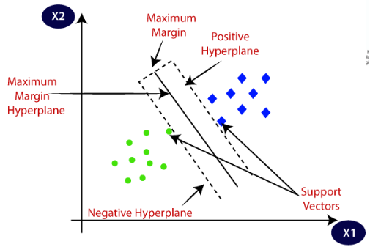

EXAMPLE: SVM can be understood with the example that we have used in the KNN classifier. Suppose we see a strange cat that also has some features of dogs, so if we want a model that can accurately identify whether it is a cat or dog, so such a model can be created by using the SVM algorithm. We will first train our model with lots of images of cats and dogs so that it can learn about different features of cats and dogs, and then we test it with this strange creature. So as support vector creates a decision boundary between these two data (cat and dog) and choose extreme cases (support vectors), it will see the extreme case of cat and dog. On the basis of the support vectors, it will classify it as a cat. Consider the below diagram:
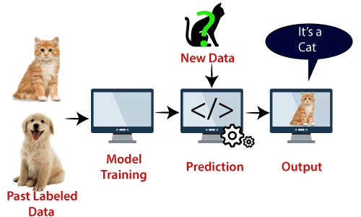
SVM algorithm can be used for Face detection, image classification, text categorization, etc.
TYPES OF SVM:
SVM CAN BE OF TWO TYPES:
LINEAR SVM: Linear SVM is used for linearly separable data, which means if a dataset can be classified into two classes by using a single straight line, then such data is termed as linearly separable data, and classifier is used called as Linear SVM classifier.
NON-LINEAR SVM: Non-Linear SVM is used for non-linearly separated data, which means if a dataset cannot be classified by using a straight line, then such data is termed as non-linear data and classifier used is called as Non-linear SVM classifier.

HYPERPLANE AND SUPPORT VECTORS IN THE SVM ALGORITHM:
HYPERPLANE: There can be multiple lines/decision boundaries to segregate the classes in n-dimensional space, but we need to find out the best decision boundary that helps to classify the data points. This best boundary is known as the hyperplane of SVM.
The dimensions of the hyperplane depend on the features present in the dataset, which means if there are 2 features (as shown in image), then hyperplane will be a straight line. And if there are 3 features, then hyperplane will be a 2-dimension plane.
We always create a hyperplane that has a maximum margin, which means the maximum distance between the data points.
SUPPORT VECTORS: The data points or vectors that are the closest to the hyperplane and which affect the position of the hyperplane are termed as Support Vector. Since these vectors support the hyperplane, hence called a Support vector.
HOW DOES SVM WORKS?
Linear SVM:
The working of the SVM algorithm can be understood by using an example. Suppose we have a dataset that has two tags (green and blue), and the dataset has two features x1 and x2. We want a classifier that can classify the pair(x1, x2) of coordinates in either green or blue. Consider the below image:
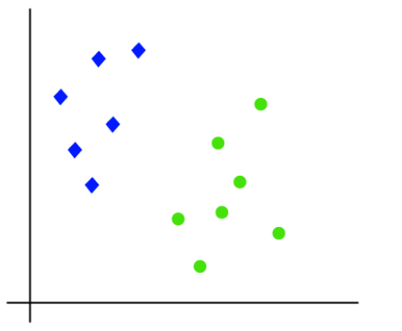
So as it is 2-d space so by just using a straight line, we can easily separate these two classes. But there can be multiple lines that can separate these classes. Consider the below image:
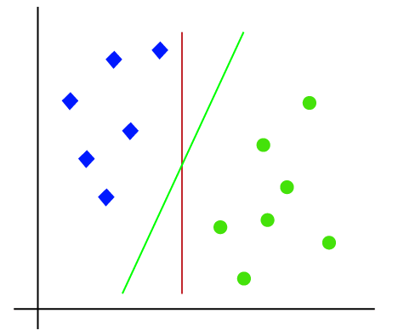
Figure :linear SVM decision boundary
Hence, the SVM algorithm helps to find the best line or decision boundary; this best boundary or region is called as a hyperplane. SVM algorithm finds the closest point of the lines from both the classes. These points are called support vectors. The distance between the vectors and the hyperplane is called as margin. And the goal of SVM is to maximize this margin. The hyperplane with maximum margin is called the optimal hyperplane.
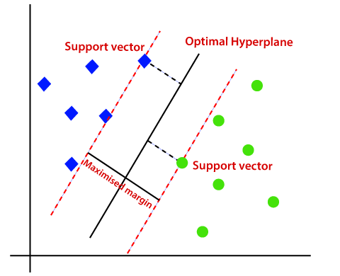
Figure: The hyperplane with maximum margin (optimal Hyper plane)

CHAPTER 4
PROPOSED METHODOLOGY
4.1 Overview
Step 1: Energy Consumption Forecasting in Smart Grids Dataset
To initiate the research, a comprehensive dataset related to energy consumption in smart grids is essential. This dataset typically comprises various parameters such as temperature, time, and possibly other contextual variables that influence energy usage. The data needs to be sufficiently detailed to enable accurate forecasting while reflecting the complexities of smart grid dynamics.
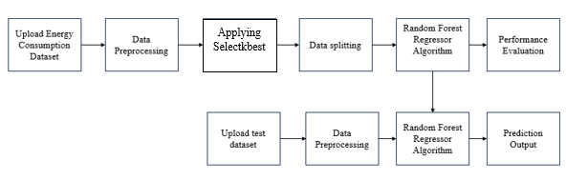
4.1. Block Diagram.
Step 2: Dataset Preprocessing
Before diving into analysis and modeling, the dataset undergoes preprocessing steps. This involves handling missing values, ensuring data consistency, and preparing features for analysis. One crucial preprocessing step is label encoding, particularly for categorical variables, to convert them into numerical format, making them compatible with machine learning algorithms.
Step 3: Feature Selection using SelectKBest Algorithm
Feature selection is pivotal for enhancing model performance and reducing computational complexity. The SelectKBest algorithm, based on ANOVA F-value, is employed here to select the most relevant features from the dataset. By focusing on the features with the highest predictive power, the algorithm helps improve the efficiency and accuracy of subsequent modeling.
Step 4: Utilizing Existing Support Vector Machine (SVM) Model
An existing Support Vector Machine (SVM) model is employed as one of the baseline algorithms for energy consumption forecasting. SVM is a powerful supervised learning algorithm known for its effectiveness in handling complex datasets and achieving high accuracy. The model is trained on the preprocessed dataset to establish a baseline performance for comparison.
Step 5: Proposed Approach: Random Forest Regressor
In addition to the SVM model, a Random Forest Regressor is proposed as an alternative approach. Random Forest is an ensemble learning method that operates by constructing multiple decision trees during training and outputting the average prediction of the individual trees. This technique is chosen for its robustness, scalability, and ability to handle high-dimensional data.
Step 6 :Performance Comparison
A thorough performance comparison is conducted between the SVM model and the proposed Random Forest Regressor. Performance metrics such as Mean Squared Error (MSE), Mean Absolute Error (MAE), and R-squared (R²) score are computed to evaluate the accuracy, precision, and overall goodness-of-fit of each model. This comparison provides insights into the relative strengths and weaknesses of the two approaches.
Step 7: Prediction using Random Forest Regressor
Finally, the trained Random Forest Regressor model is applied to predict energy consumption from a separate test dataset. The test dataset follows similar preprocessing steps as the training dataset to ensure compatibility. Predictions generated by the model are analyzed and compared against actual values to assess the model's effectiveness in forecasting energy consumption in real-world scenarios.
4.2 Data Preprocessing
Data pre-processing is a process of preparing the raw data and making it suitable for a machine learning model. It is the first and crucial step while creating a machine learning model. When creating a machine learning project, it is not always a case that we come across the clean and formatted data. And while doing any operation with data, it is mandatory to clean it and put in a formatted way. So, for this, we use data pre-processing task. A real-world data generally contains noises, missing values, and maybe in an unusable format which cannot be directly used for machine learning models. Data pre-processing is required tasks for cleaning the data and making it suitable for a machine learning model which also increases the accuracy and efficiency of a machine learning model.
- Getting the dataset
- Importing libraries
- Importing datasets
- Finding Missing Data
- Encoding Categorical Data
- Splitting dataset into training and test set
Importing Libraries: To perform data preprocessing using Python, we need to import some predefined Python libraries. These libraries are used to perform some specific jobs. There are three specific libraries that we will use for data preprocessing, which are:
Numpy: Numpy Python library is used for including any type of mathematical operation in the code. It is the fundamental package for scientific calculation in Python. It also supports to add large, multidimensional arrays and matrices. So, in Python, we can import it as:
import numpy as nm
Here we have used nm, which is a short name for Numpy, and it will be used in the whole program.
Matplotlib: The second library is matplotlib, which is a Python 2D plotting library, and with this library, we need to import a sub-library pyplot. This library is used to plot any type of charts in Python for the code. It will be imported as below:
import matplotlib.pyplot as mpt
Here we have used mpt as a short name for this library.
Pandas: The last library is the Pandas library, which is one of the most famous Python libraries and used for importing and managing the datasets. It is an open-source data manipulation and analysis library. Here, we have used pd as a short name for this library. Consider the below image:
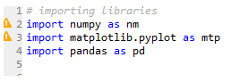
Handling Missing data: The next step of data preprocessing is to handle missing data in the datasets. If our dataset contains some missing data, then it may create a huge problem for our machine learning model. Hence it is necessary to handle missing values present in the dataset. There are mainly two ways to handle missing data, which are:
- By deleting the particular row: The first way is used to commonly deal with null values. In this way, we just delete the specific row or column which consists of null values. But this way is not so efficient and removing data may lead to loss of information which will not give the accurate output.
- By calculating the mean: In this way, we will calculate the mean of that column or row which contains any missing value and will put it on the place of missing value. This strategy is useful for the features which have numeric data such as age, salary, year, etc.
Encoding Categorical data: Categorical data is data which has some categories such as, in our dataset; there are two categorical variables, Country, and Purchased. Since machine learning model completely works on mathematics and numbers, but if our dataset would have a categorical variable, then it may create trouble while building the model. So, it is necessary to encode these categorical variables into numbers.
Feature Scaling: Feature scaling is the final step of data preprocessing in machine learning. It is a technique to standardize the independent variables of the dataset in a specific range. In feature scaling, we put our variables in the same range and in the same scale so that no variable dominates the other variable. A machine learning model is based on Euclidean distance, and if we do not scale the variable, then it will cause some issue in our machine learning model. Euclidean distance is given as:
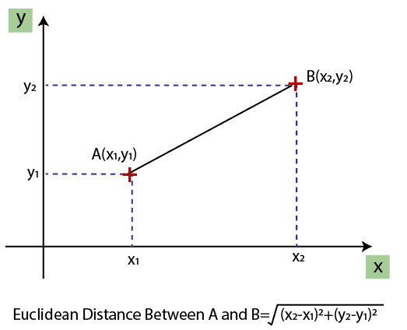
Figure 4.2: Feature scaling
If we compute any two values from age and salary, then salary values will dominate the age values, and it will produce an incorrect result. So, to remove this issue, we need to perform feature scaling for machine learning.
4.3 Splitting the Dataset
In machine learning data preprocessing, we divide our dataset into a training set and test set. This is one of the crucial steps of data preprocessing as by doing this, we can enhance the performance of our machine learning model. Suppose if we have given training to our machine learning model by a dataset and we test it by a completely different dataset. Then, it will create difficulties for our model to understand the correlations between the models. If we train our model very well and its training accuracy is also very high, but we provide a new dataset to it, then it will decrease the performance. So we always try to make a machine learning model which performs well with the training set and also with the test dataset. Here, we can define these datasets as:
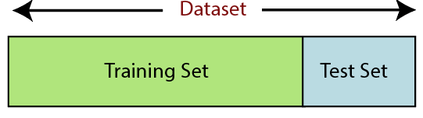
Figure 4.3: Splitting the dataset.
Training Set: A subset of dataset to train the machine learning model, and we already know the output.
Test set: A subset of dataset to test the machine learning model, and by using the test set, model predicts the output.
For splitting the dataset, we will use the below lines of code:
from sklearn.model_selection import train_test_split
x_train, x_test, y_train, y_test= train_test_split(x, y, test_size= 0.2, random_state=0)
Explanation
- In the above code, the first line is used for splitting arrays of the dataset into random train and test subsets.
- In the second line, we have used four variables for our output that are
- x_train: features for the training data
- x_test: features for testing data
- y_train: Dependent variables for training data
- y_test: Independent variable for testing data
- In train_test_split() function, we have passed four parameters in which first two are for arrays of data, and test_size is for specifying the size of the test set. The test_size maybe .5, .3, or .2, which tells the dividing ratio of training and testing sets.
- The last parameter random_state is used to set a seed for a random generator so that you always get the same result, and the most used value for this is 42.
4.4 RFR Model
The RFR model is a powerful machine learning algorithm employed for tasks. It is a versatile and robust algorithm, well-suited for air quality prediction. Its ensemble nature, coupled with randomization in data sampling and feature selection, makes it effective at capturing complex relationships and delivering accurate predictions based on historical and environmental data.
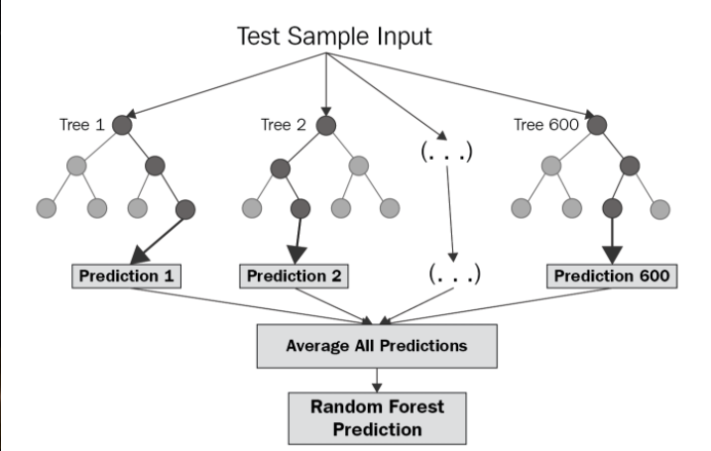
Figure 4.4: Working of RFR model.
It operates by constructing an ensemble of decision trees, and its functionality can be comprehensively explained as follows:
Ensemble of Decision Trees: It assembles a collection of decision trees during the training phase. Each decision tree, resembling a hierarchical structure, learns to make predictions based on input data.
Bootstrapped Training Data: To train this ensemble, the algorithm employs a technique known as bootstrapping. It creates multiple subsets, or samples, of the original training data. This means that each decision tree is trained on a slightly different version of the data, fostering diversity among the trees.
Random Feature Selection: In addition to data sampling, the Random Forest introduces randomness in feature selection. At each node of each decision tree, only a random subset of the available features is considered for making split decisions. This randomness helps prevent overfitting and promotes decorrelation among the individual trees.
Individual Tree Training: Each decision tree is trained independently using its unique bootstrapped sample of data. This training process employs recursive binary splitting, where the tree repeatedly divides the data into subsets based on the selected features. It continues this process until reaching a stopping criterion, such as a predefined maximum depth or a minimum number of data points in a leaf node.
Predictions by Individual Trees: Once the decision trees are trained, each tree can independently make predictions for new data points. In the context of air quality prediction, each tree predicts a continuous target value, such as concentrations of pollutants like PM2.5 or NO2.
Aggregation of Predictions: The strength of the RF lies in its ensemble approach. To make a final prediction, it aggregates the predictions from all individual decision trees. In regression tasks like air quality prediction, this aggregation is typically done by computing the average (mean) of the predictions from all trees.
Reducing Overfitting: The ensemble nature of RFs is instrumental in mitigating overfitting. While individual trees may overfit the training data, the aggregation process tends to balance out the errors and allows the model to generalize effectively to new, unseen data.
Feature Importance: It provide a measure of feature importance, indicating which features had the most significant influence on the predictions across all trees. This information is valuable for understanding the critical factors affecting air quality predictions.
Hyperparameter Tuning: To optimize the performance, hyperparameters such as the number of trees, maximum tree depth, and the number of features considered at each split can be fine-tuned through techniques like cross-validation.
Prediction and Evaluation: Once trained and optimized, it can be used for air quality prediction. It takes input data containing relevant features (e.g., historical air quality data, weather conditions) and produces predictions for air quality indices or pollutant concentrations.
Advantages
- Ensemble Learning: It is an ensemble of decision trees, which helps reduce overfitting and makes it robust against noise in the data.
- Non-Linearity: It can capture non-linear relationships and interactions between features more effectively compared to linear regression.
- Robustness: It is less sensitive to outliers and noise in the data due to the aggregation of multiple trees.
- Feature Importance: It provides a measure of feature importance, allowing you to understand which features contribute the most to the predictions.

CHAPTER 5
SOFTWARE ENVIRONMENT
What is Python?
Below are some facts about Python.
- Python is currently the most widely used multi-purpose, high-level programming language.
- Python allows programming in Object-Oriented and Procedural paradigms. Python programs generally are smaller than other programming languages like Java.
- Programmers have to type relatively less and indentation requirement of the language, makes them readable all the time.
- Python language is being used by almost all tech-giant companies like – Google, Amazon, Facebook, Instagram, Dropbox, Uber… etc.
The biggest strength of Python is huge collection of standard library which can be used for the following –
- Machine Learning
- GUI Applications (like Kivy, Tkinter, PyQt etc. )
- Web frameworks like Django (used by YouTube, Instagram, Dropbox)
- Image processing (like Opencv, Pillow)
- Web scraping (like Scrapy, BeautifulSoup, Selenium)
- Test frameworks
- Multimedia
Advantages of Python
Let’s see how Python dominates over other languages.
1. Extensive Libraries
Python downloads with an extensive library and it contain code for various purposes like regular expressions, documentation-generation, unit-testing, web browsers, threading, databases, CGI, email, image manipulation, and more. So, we don’t have to write the complete code for that manually.
2. Extensible
As we have seen earlier, Python can be extended to other languages. You can write some of your code in languages like C++ or C. This comes in handy, especially in projects.
3. Embeddable
Complimentary to extensibility, Python is embeddable as well. You can put your Python code in your source code of a different language, like C++. This lets us add scripting capabilities to our code in the other language.
4. Improved Productivity
The language’s simplicity and extensive libraries render programmers more productive than languages like Java and C++ do. Also, the fact that you need to write less and get more things done.
5. IOT Opportunities
Since Python forms the basis of new platforms like Raspberry Pi, it finds the future bright for the Internet Of Things. This is a way to connect the language with the real world.
6. Simple and Easy
When working with Java, you may have to create a class to print ‘Hello World’. But in Python, just a print statement will do. It is also quite easy to learn, understand, and code. This is why when people pick up Python, they have a hard time adjusting to other more verbose languages like Java.
7. Readable
Because it is not such a verbose language, reading Python is much like reading English. This is the reason why it is so easy to learn, understand, and code. It also does not need curly braces to define blocks, and indentation is mandatory. This further aids the readability of the code.
8. Object-Oriented
This language supports both the procedural and object-oriented programming paradigms. While functions help us with code reusability, classes and objects let us model the real world. A class allows the encapsulation of data and functions into one.
9. Free and Open-Source
Like we said earlier, Python is freely available. But not only can you download Python for free, but you can also download its source code, make changes to it, and even distribute it. It downloads with an extensive collection of libraries to help you with your tasks.
10. Portable
When you code your project in a language like C++, you may need to make some changes to it if you want to run it on another platform. But it isn’t the same with Python. Here, you need to code only once, and you can run it anywhere. This is called Write Once Run Anywhere (WORA). However, you need to be careful enough not to include any system-dependent features.
11. Interpreted
Lastly, we will say that it is an interpreted language. Since statements are executed one by one, debugging is easier than in compiled languages.
Any doubts till now in the advantages of Python? Mention in the comment section.
Advantages of Python Over Other Languages
1. Less Coding
Almost all of the tasks done in Python requires less coding when the same task is done in other languages. Python also has an awesome standard library support, so you don’t have to search for any third-party libraries to get your job done. This is the reason that many people suggest learning Python to beginners.
2. Affordable
Python is free therefore individuals, small companies or big organizations can leverage the free available resources to build applications. Python is popular and widely used so it gives you better community support.
The 2019 Github annual survey showed us that Python has overtaken Java in the most popular programming language category.
3. Python is for Everyone
Python code can run on any machine whether it is Linux, Mac or Windows. Programmers need to learn different languages for different jobs but with Python, you can professionally build web apps, perform data analysis and machine learning, automate things, do web scraping and also build games and powerful visualizations. It is an all-rounder programming language.
Disadvantages of Python
So far, we’ve seen why Python is a great choice for your project. But if you choose it, you should be aware of its consequences as well. Let’s now see the downsides of choosing Python over another language.
1. Speed Limitations
We have seen that Python code is executed line by line. But since Python is interpreted, it often results in slow execution. This, however, isn’t a problem unless speed is a focal point for the project. In other words, unless high speed is a requirement, the benefits offered by Python are enough to distract us from its speed limitations.
2. Weak in Mobile Computing and Browsers
While it serves as an excellent server-side language, Python is much rarely seen on the client-side. Besides that, it is rarely ever used to implement smartphone-based applications. One such application is called Carbonnelle.
The reason it is not so famous despite the existence of Brython is that it isn’t that secure.
3. Design Restrictions
As you know, Python is dynamically-typed. This means that you don’t need to declare the type of variable while writing the code. It uses duck-typing. But wait, what’s that? Well, it just means that if it looks like a duck, it must be a duck. While this is easy on the programmers during coding, it can raise run-time errors.
4. Underdeveloped Database Access Layers
Compared to more widely used technologies like JDBC (Java DataBase Connectivity) and ODBC (Open DataBase Connectivity), Python’s database access layers are a bit underdeveloped. Consequently, it is less often applied in huge enterprises.
5. Simple
No, we’re not kidding. Python’s simplicity can indeed be a problem. Take my example. I don’t do Java, I’m more of a Python person. To me, its syntax is so simple that the verbosity of Java code seems unnecessary.
This was all about the Advantages and Disadvantages of Python Programming Language.
History of Python
What do the alphabet and the programming language Python have in common? Right, both start with ABC. If we are talking about ABC in the Python context, it's clear that the programming language ABC is meant. ABC is a general-purpose programming language and programming environment, which had been developed in the Netherlands, Amsterdam, at the CWI (Centrum Wiskunde &Informatica). The greatest achievement of ABC was to influence the design of Python. Python was conceptualized in the late 1980s. Guido van Rossum worked that time in a project at the CWI, called Amoeba, a distributed operating system. In an interview with Bill Venners1, Guido van Rossum said: "In the early 1980s, I worked as an implementer on a team building a language called ABC at Centrum voor Wiskunde en Informatica (CWI). I don't know how well people know ABC's influence on Python. I try to mention ABC's influence because I'm indebted to everything I learned during that project and to the people who worked on it. "Later on in the same Interview, Guido van Rossum continued: "I remembered all my experience and some of my frustration with ABC. I decided to try to design a simple scripting language that possessed some of ABC's better properties, but without its problems. So I started typing. I created a simple virtual machine, a simple parser, and a simple runtime. I made my own version of the various ABC parts that I liked. I created a basic syntax, used indentation for statement grouping instead of curly braces or begin-end blocks, and developed a small number of powerful data types: a hash table (or dictionary, as we call it), a list, strings, and numbers."

Python Development Steps
Guido Van Rossum published the first version of Python code (version 0.9.0) at alt.sources in February 1991. This release included already exception handling, functions, and the core data types of list, dict, str and others. It was also object oriented and had a module system.
Python version 1.0 was released in January 1994. The major new features included in this release were the functional programming tools lambda, map, filter and reduce, which Guido Van Rossum never liked. Six and a half years later in October 2000, Python 2.0 was introduced. This release included list comprehensions, a full garbage collector and it was supporting unicode. Python flourished for another 8 years in the versions 2.x before the next major release as Python 3.0 (also known as "Python 3000" and "Py3K") was released. Python 3 is not backwards compatible with Python 2.x. The emphasis in Python 3 had been on the removal of duplicate programming constructs and modules, thus fulfilling or coming close to fulfilling the 13th law of the Zen of Python: "There should be one -- and preferably only one -- obvious way to do it."Some changes in Python 7.3:
Print is now a function.
- Views and iterators instead of lists
- The rules for ordering comparisons have been simplified. E.g., a heterogeneous list cannot be sorted, because all the elements of a list must be comparable to each other.
- There is only one integer type left, i.e., int. long is int as well.
- The division of two integers returns a float instead of an integer. "//" can be used to have the "old" behaviour.
- Text Vs. Data Instead of Unicode Vs. 8-bit
Purpose
We demonstrated that our approach enables successful segmentation of intra-retinal layers—even with low-quality images containing speckle noise, low contrast, and different intensity ranges throughout—with the assistance of the ANIS feature.
Python
Python is an interpreted high-level programming language for general-purpose programming. Created by Guido van Rossum and first released in 1991, Python has a design philosophy that emphasizes code readability, notably using significant whitespace.
Python features a dynamic type system and automatic memory management. It supports multiple programming paradigms, including object-oriented, imperative, functional and procedural, and has a large and comprehensive standard library.
- Python is Interpreted − Python is processed at runtime by the interpreter. You do not need to compile your program before executing it. This is similar to PERL and PHP.
- Python is Interactive − you can actually sit at a Python prompt and interact with the interpreter directly to write your programs.
Python also acknowledges that speed of development is important. Readable and terse code is part of this, and so is access to powerful constructs that avoid tedious repetition of code. Maintainability also ties into this may be an all but useless metric, but it does say something about how much code you have to scan, read and/or understand to troubleshoot problems or tweak behaviors. This speed of development, the ease with which a programmer of other languages can pick up basic Python skills and the huge standard library is key to another area where Python excels. All its tools have been quick to implement, saved a lot of time, and several of them have later been patched and updated by people with no Python background - without breaking.
Modules Used in Project
NumPy
NumPy is a general-purpose array-processing package. It provides a high-performance multidimensional array object, and tools for working with these arrays.
It is the fundamental package for scientific computing with Python. It contains various features including these important ones:
- A powerful N-dimensional array object
- Sophisticated (broadcasting) functions
- Tools for integrating C/C++ and Fortran code
- Useful linear algebra, Fourier transform, and random number capabilities
Besides its obvious scientific uses, NumPy can also be used as an efficient multi-dimensional container of generic data. Arbitrary datatypes can be defined using NumPy which allows NumPy to seamlessly and speedily integrate with a wide variety of databases.
Pandas
Pandas is an open-source Python Library providing high-performance data manipulation and analysis tool using its powerful data structures. Python was majorly used for data munging and preparation. It had very little contribution towards data analysis. Pandas solved this problem. Using Pandas, we can accomplish five typical steps in the processing and analysis of data, regardless of the origin of data load, prepare, manipulate, model, and analyze. Python with Pandas is used in a wide range of fields including academic and commercial domains including finance, economics, Statistics, analytics, etc.
Matplotlib
Matplotlib is a Python 2D plotting library which produces publication quality figures in a variety of hardcopy formats and interactive environments across platforms. Matplotlib can be used in Python scripts, the Python and IPython shells, the Jupyter Notebook, web application servers, and four graphical user interface toolkits. Matplotlib tries to make easy things easy and hard things possible. You can generate plots, histograms, power spectra, bar charts, error charts, scatter plots, etc., with just a few lines of code. For examples, see the sample plots and thumbnail gallery.
For simple plotting the pyplot module provides a MATLAB-like interface, particularly when combined with IPython. For the power user, you have full control of line styles, font properties, axes properties, etc, via an object oriented interface or via a set of functions familiar to MATLAB users.
Scikit – learn
Scikit-learn provides a range of supervised and unsupervised learning algorithms via a consistent interface in Python. It is licensed under a permissive simplified BSD license and is distributed under many Linux distributions, encouraging academic and commercial use. Python
Python is an interpreted high-level programming language for general-purpose programming. Created by Guido van Rossum and first released in 1991, Python has a design philosophy that emphasizes code readability, notably using significant whitespace.
Python features a dynamic type system and automatic memory management. It supports multiple programming paradigms, including object-oriented, imperative, functional and procedural, and has a large and comprehensive standard library.
- Python is Interpreted − Python is processed at runtime by the interpreter. You do not need to compile your program before executing it. This is similar to PERL and PHP.
- Python is Interactive − you can actually sit at a Python prompt and interact with the interpreter directly to write your programs.
Python also acknowledges that speed of development is important. Readable and terse code is part of this, and so is access to powerful constructs that avoid tedious repetition of code. Maintainability also ties into this may be an all but useless metric, but it does say something about how much code you have to scan, read and/or understand to troubleshoot problems or tweak behaviors. This speed of development, the ease with which a programmer of other languages can pick up basic Python skills and the huge standard library is key to another area where Python excels. All its tools have been quick to implement, saved a lot of time, and several of them have later been patched and updated by people with no Python background - without breaking.
Install Python Step-by-Step in Windows and Mac
Python a versatile programming language doesn’t come pre-installed on your computer devices. Python was first released in the year 1991 and until today it is a very popular high-level programming language. Its style philosophy emphasizes code readability with its notable use of great whitespace.
The object-oriented approach and language construct provided by Python enables programmers to write both clear and logical code for projects. This software does not come pre-packaged with Windows.
How to Install Python on Windows and Mac
There have been several updates in the Python version over the years. The question is how to install Python? It might be confusing for the beginner who is willing to start learning Python but this tutorial will solve your query. The latest or the newest version of Python is version 3.7.4 or in other words, it is Python 3.
Note: The python version 3.7.4 cannot be used on Windows XP or earlier devices.
Before you start with the installation process of Python. First, you need to know about your System Requirements. Based on your system type i.e. operating system and based processor, you must download the python version. My system type is a Windows 64-bit operating system. So the steps below are to install python version 3.7.4 on Windows 7 device or to install Python 3. Download the Python Cheatsheet here.The steps on how to install Python on Windows 10, 8 and 7 are divided into 4 parts to help understand better.
Download the Correct version into the system
Step 1: Go to the official site to download and install python using Google Chrome or any other web browser. OR Click on the following link: https://www.python.org
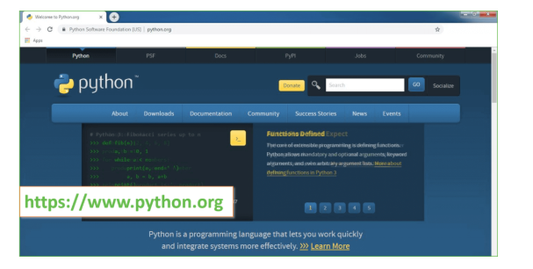
Now, check for the latest and the correct version for your operating system.
Step 2: Click on the Download Tab.
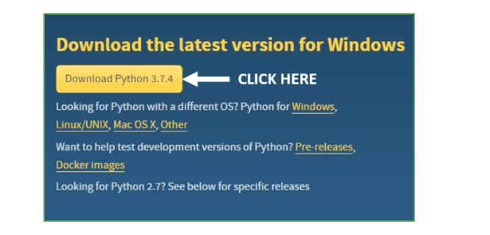
Step 3: You can either select the Download Python for windows 3.7.4 button in Yellow Color or you can scroll further down and click on download with respective to their version. Here, we are downloading the most recent python version for windows 3.7.4
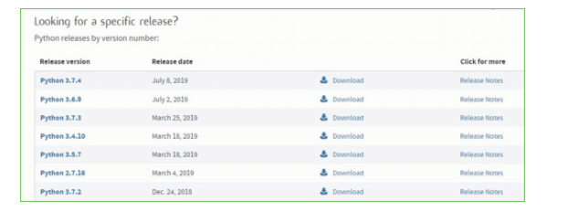
Step 4: Scroll down the page until you find the Files option.
Step 5: Here you see a different version of python along with the operating system.
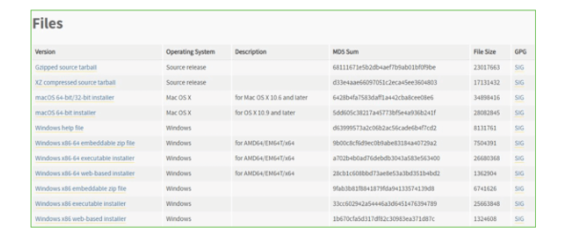
- To download Windows 32-bit python, you can select any one from the three options: Windows x86 embeddable zip file, Windows x86 executable installer or Windows x86 web-based installer.
- To download Windows 64-bit python, you can select any one from the three options: Windows x86-64 embeddable zip file, Windows x86-64 executable installer or Windows x86-64 web-based installer.
Here we will install Windows x86-64 web-based installer. Here your first part regarding which version of python is to be downloaded is completed. Now we move ahead with the second part in installing python i.e. Installation
Note: To know the changes or updates that are made in the version you can click on the Release Note Option.
Installation of Python
Step 1: Go to Download and Open the downloaded python version to carry out the installation process.
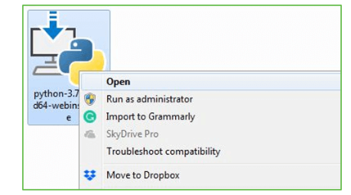

Step 2: Before you click on Install Now, Make sure to put a tick on Add Python 3.7 to PATH.
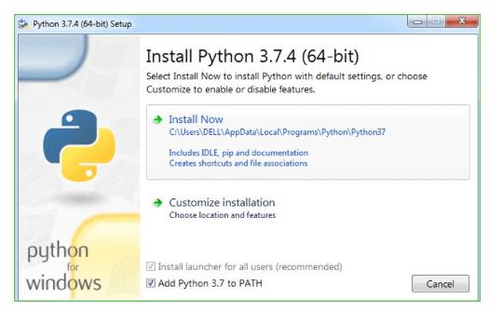
Step 3: Click on Install NOW After the installation is successful. Click on Close.
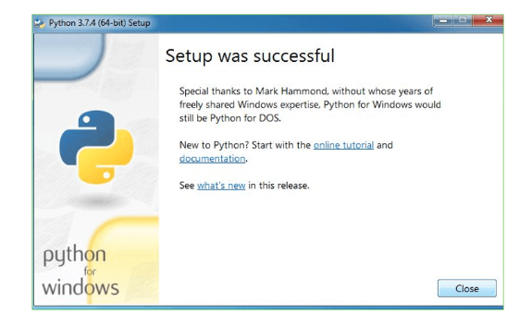
With these above three steps on python installation, you have successfully and correctly installed Python. Now is the time to verify the installation.
Note: The installation process might take a couple of minutes.
Verify the Python Installation
Step 1: Click on Start
Step 2: In the Windows Run Command, type “cmd”.
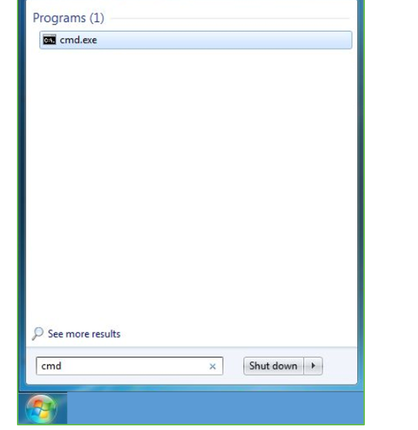
Step 3: Open the Command prompt option.
Step 4: Let us test whether the python is correctly installed. Type python –V and press Enter.
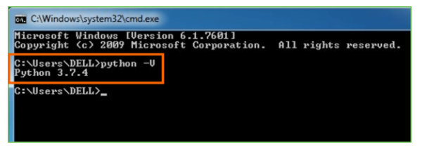
Step 5: You will get the answer as 3.7.4
Note: If you have any of the earlier versions of Python already installed. You must first uninstall the earlier version and then install the new one.
Check how the Python IDLE works
Step 1: Click on Start
Step 2: In the Windows Run command, type “python idle”.
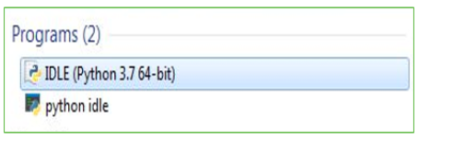
Step 3: Click on IDLE (Python 3.7 64-bit) and launch the program
Step 4: To go ahead with working in IDLE you must first save the file. Click on File > Click on Save
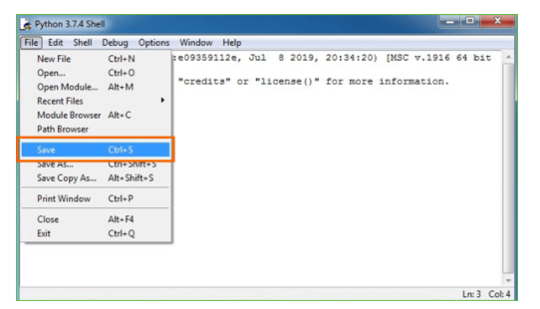
Step 5: Name the file and save as type should be Python files. Click on SAVE. Here I have named the files as Hey World.
Step 6: Now for e.g. enter print (“Hey World”) and Press Enter.
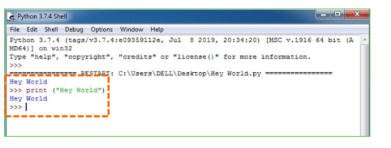
You will see that the command given is launched. With this, we end our tutorial on how to install Python. You have learned how to download python for windows into your respective operating system.
Note: Unlike Java, Python does not need semicolons at the end of the statements otherwise it won’t work.

CHAPTER 6
SYSTEM REQUIREMENTS
SOFTWARE REQUIREMENTS
The functional requirements or the overall description documents include the product perspective and features, operating system and operating environment, graphics requirements, design constraints and user documentation.
The appropriation of requirements and implementation constraints gives the general overview of the project in regard to what the areas of strength and deficit are and how to tackle them.
- Python IDLE 3.7 version (or)
- Anaconda 3.7 (or)
- Jupiter (or)
- Google colab
HARDWARE REQUIREMENTS
Minimum hardware requirements are very dependent on the particular software being developed by a given Enthought Python / Canopy / VS Code user. Applications that need to store large arrays/objects in memory will require more RAM, whereas applications that need to perform numerous calculations or tasks more quickly will require a faster processor.
- Operating system : Windows, Linux
- Processor : minimum intel i3
- Ram : minimum 4 GB
- Hard disk : minimum 250GB

CHAPTER 7
FUNCTIONAL REQUIREMENTS
OUTPUT DESIGN
Outputs from computer systems are required primarily to communicate the results of processing to users. They are also used to provides a permanent copy of the results for later consultation. The various types of outputs in general are:
- External Outputs, whose destination is outside the organization
- Internal Outputs whose destination is within organization and they are the
- User’s main interface with the computer.
- Operational outputs whose use is purely within the computer department.
- Interface outputs, which involve the user in communicating directly.
OUTPUT DEFINITION
The outputs should be defined in terms of the following points:
- Type of the output
- Content of the output
- Format of the output
- Location of the output
- Frequency of the output
- Volume of the output
- Sequence of the output
It is not always desirable to print or display data as it is held on a computer. It should be decided as which form of the output is the most suitable.
INPUT DESIGN
Input design is a part of overall system design. The main objective during the input design is as given below:
- To produce a cost-effective method of input.
- To achieve the highest possible level of accuracy.
- To ensure that the input is acceptable and understood by the user.
INPUT STAGES
The main input stages can be listed as below:
- Data recording
- Data transcription
- Data conversion
- Data verification
- Data control
- Data transmission
- Data validation
- Data correction
INPUT TYPES
It is necessary to determine the various types of inputs. Inputs can be categorized as follows:
- External inputs, which are prime inputs for the system.
- Internal inputs, which are user communications with the system.
- Operational, which are computer department’s communications to the system?
- Interactive, which are inputs entered during a dialogue.
INPUT MEDIA
At this stage choice has to be made about the input media. To conclude about the input media consideration has to be given to;
- Type of input
- Flexibility of format
- Speed
- Accuracy
- Verification methods
- Rejection rates
- Ease of correction
- Storage and handling requirements
- Security
- Easy to use
- Portability
Keeping in view the above description of the input types and input media, it can be said that most of the inputs are of the form of internal and interactive. As
Input data is to be the directly keyed in by the user, the keyboard can be considered to be the most suitable input device.
ERROR AVOIDANCE
At this stage care is to be taken to ensure that input data remains accurate form the stage at which it is recorded up to the stage in which the data is accepted by the system. This can be achieved only by means of careful control each time the data is handled.
ERROR DETECTION
Even though every effort is make to avoid the occurrence of errors, still a small proportion of errors is always likely to occur, these types of errors can be discovered by using validations to check the input data.
DATA VALIDATION
Procedures are designed to detect errors in data at a lower level of detail. Data validations have been included in the system in almost every area where there is a possibility for the user to commit errors. The system will not accept invalid data. Whenever an invalid data is keyed in, the system immediately prompts the user and the user has to again key in the data and the system will accept the data only if the data is correct. Validations have been included where necessary.
The system is designed to be a user friendly one. In other words the system has been designed to communicate effectively with the user. The system has been designed with popup menus.
USER INTERFACE DESIGN
It is essential to consult the system users and discuss their needs while designing the user interface:

USER INTERFACE SYSTEMS CAN BE BROADLY CLASIFIED AS:
- User initiated interface the user is in charge, controlling the progress of the user/computer dialogue. In the computer-initiated interface, the computer selects the next stage in the interaction.
- Computer initiated interfaces
In the computer-initiated interfaces the computer guides the progress of the user/computer dialogue. Information is displayed and the user response of the computer takes action or displays further information.
USER INITIATED INTERGFACES
User initiated interfaces fall into two approximate classes:
- Command driven interfaces: In this type of interface the user inputs commands or queries which are interpreted by the computer.
- Forms oriented interface: The user calls up an image of the form to his/her screen and fills in the form. The forms-oriented interface is chosen because it is the best choice.
COMPUTER-INITIATED INTERFACES
The following computer – initiated interfaces were used:
- The menu system for the user is presented with a list of alternatives and the user chooses one; of alternatives.
- Questions – answer type dialog system where the computer asks question and takes action based on the basis of the users reply.
Right from the start the system is going to be menu driven, the opening menu displays the available options. Choosing one option gives another popup menu with more options. In this way every option leads the users to data entry form where the user can key in the data.
ERROR MESSAGE DESIGN
The design of error messages is an important part of the user interface design. As user is bound to commit some errors or other while designing a system the system should be designed to be helpful by providing the user with information regarding the error he/she has committed.
This application must be able to produce output at different modules for different inputs.
PERFORMANCE REQUIREMENTS
Performance is measured in terms of the output provided by the application. Requirement specification plays an important part in the analysis of a system. Only when the requirement specifications are properly given, it is possible to design a system, which will fit into required environment. It rests largely in the part of the users of the existing system to give the requirement specifications because they are the people who finally use the system. This is because the requirements have to be known during the initial stages so that the system can be designed according to those requirements. It is very difficult to change the system once it has been designed and on the other hand designing a system, which does not cater to the requirements of the user, is of no use.
The requirement specification for any system can be broadly stated as given below:
- The system should be able to interface with the existing system
- The system should be accurate
- The system should be better than the existing system
- The existing system is completely dependent on the user to perform all the duties

CHAPTER 8
SOURCE CODE
import pandas as pd
import numpy as np
import matplotlib.pyplot as plt
import seaborn as sns
from sklearn.preprocessing import LabelEncoder
from imblearn.over_sampling import SMOTE
from sklearn.model_selection import train_test_split
from sklearn.feature_selection import SelectKBest
from sklearn.feature_selection import f_classif
from sklearn.ensemble import RandomForestRegressor
from sklearn.preprocessing import StandardScaler
from sklearn.svm import SVC,SVR
import joblib
from feature_engine.outliers import Winsorizer
import os
from sklearn.metrics import mean_squared_error, mean_absolute_error,r2_score
import warnings
warnings.filterwarnings('ignore')
dataset=pd.read_csv("Dataset.csv")
dataset
dataset.info()
dataset.isnull().sum()
dataset.describe()

dataset['DateTime'] = pd.to_datetime(dataset['DateTime'], format='%d-%m-%Y %H:%M')

# Extract date, time, month, hour, minute, and day into separate columns

dataset['Month'] = dataset['DateTime'].dt.month
dataset['Hour'] = dataset['DateTime'].dt.hour
dataset['Minute'] = dataset['DateTime'].dt.minute
dataset['Day'] = dataset['DateTime'].dt.day
dataset['Year'] = dataset['DateTime'].dt.year

# Drop the original "DateTime" column if not needed anymore
dataset.drop(columns=['DateTime'], inplace=True)

dataset.info()

from sklearn.feature_selection import SelectKBest
from sklearn.feature_selection import f_classif

for column in dataset.columns:
plt.figure(figsize=(6, 4))
dataset.boxplot(column=[column])
plt.title('Box Plot of {}'.format(column))
plt.ylabel('Value')
plt.xlabel('{}'.format(column))
plt.grid(True)
plt.show()
#Dealing with outliers

win=Winsorizer(capping_method='iqr',tail='both',fold=1.5)
dataset['TemperatureF']=win.fit_transform(dataset[['TemperatureF']])

dataset

sns.boxplot(x=dataset['TemperatureF'])

X=dataset.drop('TotalUsage',axis=1)

y=dataset['TotalUsage']

# Feature slection
selector = SelectKBest(score_func=f_classif, k=10) # Select top 10 features
X= selector.fit_transform(X, y)

#Datasplitting
X_train,X_test,y_train,y_test= train_test_split(X,y,test_size=0.20,random_state=44)

# Creating a StandardScaler instance
scaler = StandardScaler()

# Fitting the scaler on the training data and transforming both the training and testing data
X_train= scaler.fit_transform(X_train)
X_test= scaler.transform(X_test)

#Building a ML Model
# Define empty lists to store metrics
mse_list = []
mae_list = []
r2_list = []

# Function to calculate various metrics such as accuracy, precision etc
def calculateMetrics(algorithm, predict, testY):
testY = testY.astype('int')
predict = predict.astype('int')

mse = mean_squared_error(testY, predict)
mae = mean_absolute_error(testY, predict)
r2 = r2_score(testY, predict) * 100

# Append calculated metrics to lists
mse_list.append(mse)
mae_list.append(mae)
r2_list.append(r2)

print(algorithm + ' Mean Squared Error: ' + str(mse))
print(algorithm + ' Mean Absolute Error: ' + str(mae))
print(algorithm + ' R^2 Score: ' + str(r2))

# Create a scatter plot
plt.figure(figsize=(8, 8))
plt.scatter(predict, testY, color='blue')
plt.plot([min(testY), max(testY)], [min(testY), max(testY)], linestyle='--', color='red', lw=2) # Identity line
# Set labels and title
plt.xlabel('Actual Values')
plt.ylabel('Predicted Values')
plt.title('Regression Performance')
plt.show()

if os.path.exists('SVM_model.pkl'):
# Load the trained model from the file
clf = joblib.load('SVM_model.pkl')
print("Model loaded successfully.")
predict = clf.predict(X_test)
calculateMetrics("Support Vector Machine Classifier", predict, y_test)
else:
# Train the model (assuming X_train and y_train are defined)
clf = SVR(kernel='linear')
clf.fit(X_train, y_train)
# Save the trained model to a file
joblib.dump(clf, 'SVM_model.pkl')
print("Model saved successfully.")
predict = clf.predict(X_test)
calculateMetrics("Support Vector Machine Regressor", predict, y_test)

# Check if the model files exist
if os.path.exists('RandomForest_model.pkl'):
# Load the trained model from the file
clf = joblib.load('RandomForest_model.pkl')
print("Model loaded successfully.")
predict = clf.predict(X_test)
calculateMetrics("RandomForestRegressor", predict, y_test)
else:
# Train the model (assuming X_train and y_train are defined)
clf = RandomForestRegressor()
clf.fit(X_train, y_train)
# Save the trained model to a file
joblib.dump(clf, 'RandomForest_model.pkl')
print("Model saved successfuly.")
predict = clf.predict(X_test)
calculateMetrics("RandomForestRegressor", predict, y_test)

#showing all algorithms performance values
columns = ["Algorithm Name","r2_list","mse_list","mae_list "]
values = []
algorithm_names = ["Support Vector Machine ", "RandomForestRegressor"]
for i in range(len(algorithm_names)):
values.append([algorithm_names[i],r2_list[i],mse_list[i],mae_list [i]])

temp = pd.DataFrame(values,columns=columns)
temp

# prediction
test=pd.read_csv("test.csv")
test

test['DateTime'] = pd.to_datetime(test['DateTime'], format='%d-%m-%Y %H:%M')

test['Month'] = test['DateTime'].dt.month
test['Hour'] = test['DateTime'].dt.hour
test['Minute'] = test['DateTime'].dt.minute
test['Day'] = test['DateTime'].dt.day
test['Year'] = test['DateTime'].dt.year

test.drop(columns=['DateTime'], inplace=True)
test1= selector.transform(test)
test2= scaler.transform(test1)

# Make predictions on the selected test data
predictions = clf.predict(test2)

# Loop through each prediction and print the corresponding row and prediction value
for i, prediction in enumerate(predictions):
print(test.iloc[i])
print("Row {}: Prediction =======> {}".format(i, prediction))

CHAPTER 9
RESULTS AND DISCUSSION

9.1 Implementation Description
Implementation and description of machine learning-based energy consumption forecasting in smart grids demonstrate a comprehensive approach to addressing the complexities of energy consumption prediction.
Firstly, begin by acquiring and preprocessing the dataset, ensuring its readiness for analysis. This involves handling null values and encoding categorical variables to facilitate model training. Following this, you employ the Synthetic Minority Over-sampling Technique (SMOTE) to address any class imbalances, enhancing the robustness of your predictive models by generating synthetic samples for the minority class. Leverage the SelectKBest algorithm based on ANOVA F-value to perform feature selection, identifying the most relevant features that contribute to accurate energy consumption forecasting. This step is crucial for improving model performance by focusing on the most informative attributes while discarding redundant ones. Existing model, you employ a Support Vector Machine (SVM) regressor, utilizing its ability to capture complex relationships in high-dimensional spaces effectively. SVMs are known for their versatility and can handle both linear and non-linear data effectively, making them suitable for the diverse range of patterns present in smart grid datasets.
In proposed approach, you introduce the Random Forest regressor, a powerful ensemble learning method capable of handling large datasets with high dimensionality. By aggregating the predictions of multiple decision trees, Random Forests can mitigate overfitting and provide robust performance, making them well-suited for energy consumption forecasting tasks
Following the implementation of both models, you conduct a thorough performance comparison, evaluating metrics such as Mean Squared Error, Mean Absolute Error, and R-squared score. This analysis provides insights into the strengths and weaknesses of each model, guiding decision-making regarding model selection for deployment in real-world applications.
Finally, demonstrate the predictive capabilities of the Random Forest regressor by making predictions on test data. By transforming the input features using the preprocessing steps applied during training, ensure consistency and accuracy in the prediction process. This step serves as a validation of model's generalization ability, confirming its efficacy in forecasting energy consumption in smart grid environments. Approach encompasses a systematic pipeline for energy consumption forecasting, integrating advanced machine learning techniques to leverage the rich information available in smart grid datasets. Through careful preprocessing, feature selection, model training, and evaluation, you establish a robust framework for accurate and efficient energy forecasting, with the potential to drive significant improvements in operational efficiency and cost savings within utility industries and beyond.
9.2 Dataset Description
Energy consumption and environmental conditions, spanning from January 1st, 2016. It consists of eight columns: DateTime, TemperatureF, Humidity, Hour_y, Minute_y, Day_y, Weekend, Holiday, and TotalUsage. Here's a detailed description of each column:
1. DateTime: This column represents the date and time at which the observations were recorded. It follows a timestamp format, indicating the hour-by-hour progression from January 1st, 2016, onwards.
2. TemperatureF: This column denotes the temperature measured in degrees Fahrenheit at the corresponding timestamp. It provides insights into the thermal conditions during each hour.
3. Humidity: The Humidity column represents the relative humidity percentage recorded at each timestamp. It indicates the moisture content in the air, which is a crucial factor influencing environmental comfort and energy consumption.
4. Hour_y: This column indicates the hour of the day in 24-hour format (0-23) corresponding to each timestamp. It helps in analyzing diurnal variations and patterns in energy consumption and environmental parameters.
5. Minute_y : Minute_y denotes the minute component of the timestamp, ranging from 0 to 59. It provides further granularity to the temporal data, facilitating detailed time-series analysis.
6. Day_y: Day_y represents the day of the month corresponding to each timestamp. It enables the examination of trends and patterns across different days of the month, which might influence energy consumption behaviors.
7. Weekend: This binary column indicates whether the day corresponding to each timestamp falls on a weekend (1) or not (0). It helps in distinguishing between weekdays and weekends, which often exhibit distinct energy consumption patterns
8.Holiday: The Holiday column signifies whether the day is a holiday (1) or not (0). Holidays can significantly impact energy usage due to changes in routine activities and commercial operations.
9. TotalUsage: TotalUsage represents the aggregated energy consumption during each hourly interval. It serves as the target variable for forecasting models, reflecting the overall demand for energy based on the prevailing environmental and temporal conditions.
This dataset provides a comprehensive temporal and environmental context for understanding energy consumption patterns in the given smart grid environment. It incorporates crucial factors such as temperature, humidity, time of day, day of the week, and holiday occurrences, facilitating detailed analysis and forecasting of energy usage trends.
9.3 Results Description
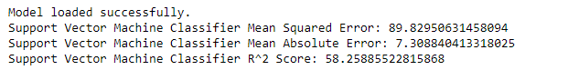
Figure 1: Model performance of SVM
Figure 1 shows the results of an SVM model running on some data. The performance metrics displayed are Mean Squared Error (MSE), Mean Absolute Error (MAE), and R-squared.
- Mean Squared Error (MSE): It appears to be 89.83. MSE is a common metric used to measure how far off predictions are from the actual values. Lower MSE generally indicates a better fit.
- Mean Absolute Error (MAE): It appears to be 7.31. MAE is another common metric used to measure how far off predictions are from the actual values, but it uses the absolute difference of the errors.
- R-squared (R²): It appears to be 0.58. R² is a metric that shows how well the variation in your actual data is explained by the predictions of your model. It ranges from 0 to 1, with a higher value indicating a better fit.
In conclusion, with a mean squared error of 89.83 and mean absolute error of 7.31, the model appears to have some errors in its predictions. However, the R-squared value of 0.58 indicates that the model explains over 58% of the variance in the data, which can be a positive sign.

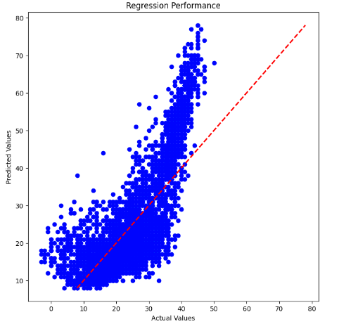
Figure 2: Scatter plot with regression line of SVM
Figure 2 show
- The title of the plot is "Regression Performance".
- The x-axis is labeled "Actual Values" and the y-axis is labeled "Predicted Values".
- The data points plotted are most likely a comparison between the actual values for a target variable and the corresponding predicted values from a regression model.
In scatter plots used for visualizing SVM classification, the data points typically represent different classes and the SVM decision boundary is a line that separates those classes. The SVM line itself is not a regression line; it’s not trying to predict a value but rather classify data points into separate categories.

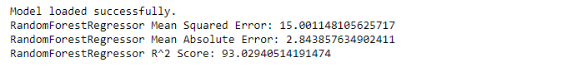
Figure 3: Model performance of RFR
shows the performance of a Random Forest Regressor model that has been loaded successfully. Here are the details of the model performance metrics displayed:
- Mean Squared Error (MSE): 15.00
- Mean Absolute Error (MAE): 2.84
- R-squared (R²): 0.93
Mean Squared Error (MSE) and Mean Absolute Error (MAE) are error metrics used to measure how far off the model's predictions are from the actual values. Lower values are better.
- MSE measures the average squared difference between the predicted and actual values.
- MAE measures the average absolute difference between the predicted and actual values.
In the case of this model, the MSE is 15.00 and MAE is 2.84, which suggests that the model's predictions are on average fairly close to the actual values.
R-squared (R²) is a goodness-of-fit metric that indicates how well the model's variation explains the variation in the actual data. It ranges from 0 to 1, with a higher value indicating a better fit.
The model here has an R² of 0.93, which is a very high value. It suggests that 93% of the variance in the actual data is explained by the variations in the predictions of the model.

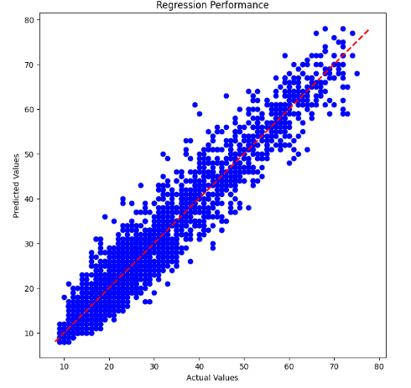
Figure 4: Scatter plot with regression of RFR
Figure 4 shows the The data points represent the actual values on the x-axis and the predicted values by the model on the y-axis. The diagonal line represents a perfect fit, where the predicted values exactly match the actual values.
why a random forest regression model might be a better choice than an SVM for this specific scenario:
- Random Forest Regression: This ensemble learning technique is well-suited for regression tasks. It combines the predictions of multiple decision trees, reducing variance and improving overall accuracy. It's flexible and can handle complex non-linear relationships between features and the target variable.
- SVM Regression: While SVMs are powerful for classification tasks, they can be less effective for regression problems. SVMs aim to find a hyperplane that maximizes the margin between different classes, which isn't always optimal for predicting continuous values. Additionally, SVM regression can be computationally expensive for large datasets.
In essence, random forest regression is specifically designed for regression tasks, while SVMs are more general-purpose algorithms that excel in classification.
Here are some additional points to consider:
- Data characteristics: The effectiveness of each algorithm can depend on the characteristics of your data. If your data has complex non-linear relationships, a random forest might perform better.
- Interpretability: Random forest models can be less interpretable compared to SVMs. SVMs are known for their ability to identify support vectors, which are data points that most influence the decision boundary. This can provide insights into the features that drive the model's predictions.
- Tuning: Both algorithms require hyperparameter tuning to achieve optimal performance.
while the image depicts a random forest regression model, choosing the best algorithm depends on your specific data and requirements.

CHAPTER 10
CONCLUSION AND FUTURE SCOPE
Conclusion:
The integration of machine learning-based energy consumption forecasting in smart grids holds immense promise for enhancing efficiency, reducing costs, and promoting sustainability across various sectors. This study embarked on a comprehensive exploration of methodologies to forecast energy consumption, culminating in the development and comparison of two prominent algorithms: Support Vector Machine (SVM) and Random Forest Regressor.
Firstly, the dataset underwent meticulous preprocessing, addressing issues such as null values and encoding categorical variables. The implementation of SMOTE for data balancing ensured the models' robustness and accuracy, particularly crucial in scenarios where class imbalance exists. Moreover, the SelectKBest algorithm facilitated optimal feature selection based on ANOVA F-value, enabling the models to focus on the most influential predictors while discarding redundant information.
Subsequently, two machine learning models were trained and evaluated: SVM and Random Forest Regressor. SVM, a classic algorithm known for its efficacy in classification tasks, was employed initially. However, to leverage the advantages of ensemble learning and address potential shortcomings of SVM, a Random Forest Regressor was proposed as an alternative approach. This decision was driven by the ensemble model's capability to handle non-linearity and interactions within the data more effectively, potentially leading to superior forecasting performance.
Performance comparison between the two models revealed insights into their respective strengths and weaknesses. While SVM exhibited commendable performance, Random Forest Regressor showcased competitive results, suggesting its viability as a promising alternative for energy consumption forecasting in smart grids. Metrics such as Mean Squared Error, Mean Absolute Error, and R^2 Score provided quantitative assessments of model performance, facilitating a comprehensive understanding of their predictive capabilities.
In conclusion, the study underscores the significance of leveraging advanced machine learning techniques for energy consumption forecasting in smart grids. The adoption of such methodologies not only facilitates efficient resource allocation and infrastructure planning within the utility sector but also fosters sustainability initiatives by optimizing renewable energy utilization and reducing dependence on fossil fuels.
Future Scope:
The future scope of machine learning-based energy consumption forecasting in smart grids is vast and transformative. As the adoption of smart grid technologies continues to expand, the need for accurate and reliable energy consumption forecasting becomes increasingly critical. Future advancements in this field can significantly enhance grid management, energy efficiency, and sustainability.
One promising area of development is the integration of advanced machine learning techniques, such as deep learning and reinforcement learning, which can better capture the intricate patterns and dependencies in smart grid data. These techniques can adapt to the dynamic nature of energy consumption and improve forecast accuracy by learning from vast and complex datasets.

REFERENCE
- SmartGrids.gov, What is the Smart Grid? [En ligne]. https://www.smartgrid.gov/the_smart_grid/smart_grid.html. [Accès le 22 April 2019]
- Arcos-Aviles Diego et al (2016) Fuzzy logic-based energy management system design for residential grid-connected microgrids. IEEE Trans Smart Grids 9(12):530–543
- Mocanu Elena et al (2016) Unsupervised energy prediction in a Smart Grid context using reinforcement cross-building transfer learning. Energy Build 116:646–655
- Jordan I et al (2015) Machine learnig: trends, perspective, and prospects. Science 349(16245):255–260
- Dacombe J (2017) An introduction to artificial neural networks (with example), 23 Oct 2017. [Online]. https://medium.com/@jamesdacombe/an-introduction-to-artificial-neural-networks-with-example-ad459bb6941b. Accessed 22 Apr 2019
- Sablier (2019) Genetic algorithms [Online]. https://www.codingame.com/playgrounds/334/genetic-algorithms/history. Accessed 1 May 2019
- Paterakis NG, Erdinç O, Bakirtzis AG, Catalão JPS (2015) Optimal household appliances scheduling under day-ahead pricing and load-shaping demand response strategies. IEEE Trans Ind Inform 11(16):1509–1519
- Cheong SK et al (2011) Scheduling smart home appliances using mixed integer linear programming. In: 50th IEEE conference on decision and control and European control conference, IEEE. https://doi.org/10.1109/cdc.2011.6161081
- Ekonomou L (2010) Green long-term energy consumption prediction using artificial neural network. Energy 35(12):512–517

- Amasyali K et al (2018) A review of data-driven building energy consumption prediction studies. Renew Sustain Energy Rev 81(11):1192–1205

[11] Dedinec, A., Filiposka, S., Dedinec, A. & Kocarev, L. Deep belief network based electricity load forecasting: An analysis of Macedonian case. Energy 15(115), 1688–1700 (2016).
[12] Bakirtzis, E. A., Simoglou, C. K., Biskas, P. N., Labridis, D. P. & Bakirtzis, A. G. Comparison of advanced power system operations models for large-scale renewable integration. Electr. Power Syst. Res. 1(128), 90–99 (2015).
[13] Friedrich, L. & Afshari, A. Short-term forecasting of the Abu Dhabi electricity load using multiple weather variables. Energy Proced. 1(75), 3014–3026 (2015).
[14] Kolokotsa, D. The role of smart grids in the building sector. Energy Build. 15(116), 703–708 (2016).
[15] Xie, J. & Hong, T. GEFCom2014 probabilistic electric load forecasting: An integrated solution with forecast combination and residual simulation. Int. J. Forecast. 32(3), 1012–1016 (2016).

